|  |
| --- |
| Bayer Healthcare |
| Doc41 Web UI User Guide |
|  |
|  |
| **Ingo Kaulbach (Bayer Business Services GmbH)** |
| **16.01.2015** |

|  |
| --- |
|  |

|  |  |
| --- | --- |
| Infobox |  |
| Applicable System: | External Access: Doc41 Web UI |
| Title: | User Guide |
| Author: | Ingo Kaulbach (EVFPU) |
| Change history (version number, last change, changed by, date) | 1. Ingo Kaulbach EVFPU, 2013-11-12, initial setup   1.1 Ingo Kaulbach EVFPU, 2014-01-15, infobox added 1.2 Ingo Kaulbach EVFPU, 2015-01-16, update |
| Current Version of document: | 1.2 |
|  |  |

Content

Login 4

Login screen 4

My Profile 5

Upload 6

Download 7

Roles 8

Carrier 8

Download: Air waybill 8

Download: Bill of Lading 8

Download: Shippers declaration 9

Download: Waybill 10

Download: FDA certificate 11

Download: CMR (outgoing) 12

Upload: CMR (incoming) 13

Upload: Air waybill 14

Upload: Bill of Lading 15

Customs Broker 16

DirectDownload: Air waybill 16

DirectDownload: Bill of Lading 16

DirectDownload: Shippers declaration 16

DirectDownload: Waybill 16

DirectDownload: FDA certificate 16

Material Supplier 17

Upload: Supplier CoA 17

Product Supplier 18

Upload: Delivery Certificate 18

ViewerCountry 19

Download: Delivery Certificate 19

ViewerCustomer 20

Download: Delivery Certificate 20

Layout Supplier 21

Download: HighRes Layout 21

Download: LowRes Artwork 22

Upload: HighRes Layout 23

PM supplier 24

Download: Packaging specification 24

Download: Technical drawing 24

Download: Technical packaging and Delivery requirements 25

Download: CMR (outgoing) 26

# Login

## Login screen

Open   
<https://doc41.bayer.com/>   
in your browser and enter your user id and password if you are already registered.

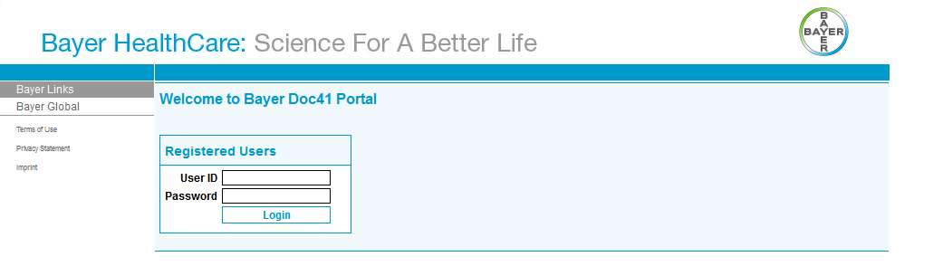

# My Profile

After you have successfully logged in, you will see the “My Profile”-page, where you can find all details of your profile.

You can see your personal details, like first- and surename, cwid, email-address and language.

You can see the roles assigned to your account.

You can also see the customer- and vendornumbers, countries and plants assigned to your account.

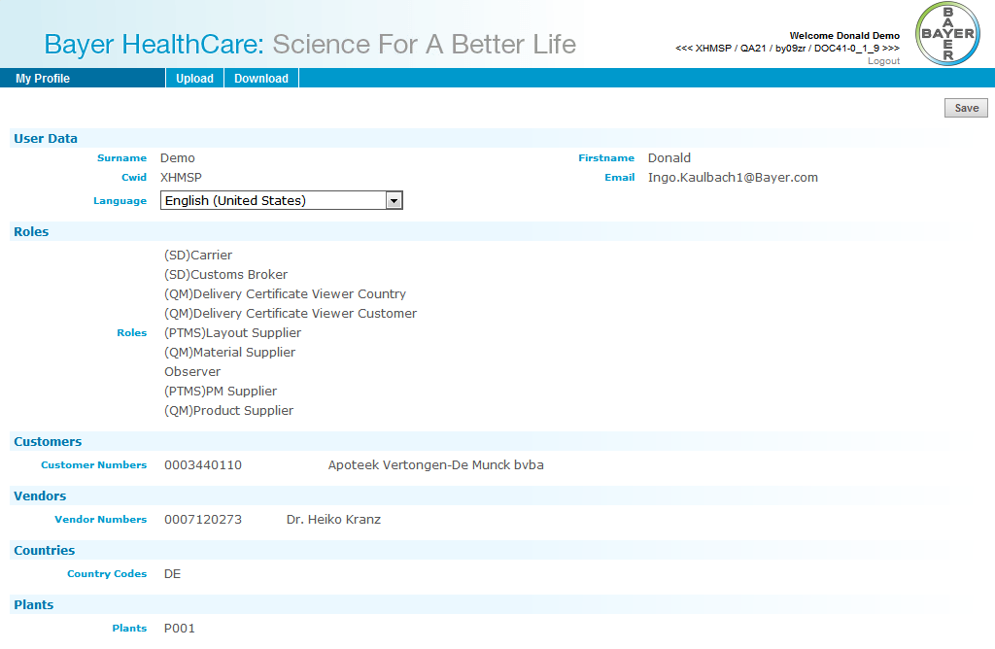

# Upload

If you have a role that allows you to upload a document you will find the Upload-tab in your top navigation menu.

Depending on your roles you will find the types of documents you can upload, for example *Bill of Lading*.

In section Roles of this document you will find which documents you can upload for a certain role.

# Download

If you have a role that allows you to download a document you will find the Download-tab in your top navigation menu.

Depending on your roles you will find the types of documents you can download, for example *Bill of Lading*.

In section Roles of this document you will find which documents you can download for a certain role.

# Roles

## (SD) Carrier

### Download: Air waybill

If you want to download an air waybill, please select “Air Waybill” from the Download-tab in your top navigation menu.

You have to select a vendor from the list. If the vendor is not in your list please contact your administrator.

You have to enter the reference number of the document.

Optional you can enter the exact filename.

Optional you can enter the exact TM/3 planing point name.

All found documents will be displayed in the Results-table.

To download a file you just have to click on the row of the file.

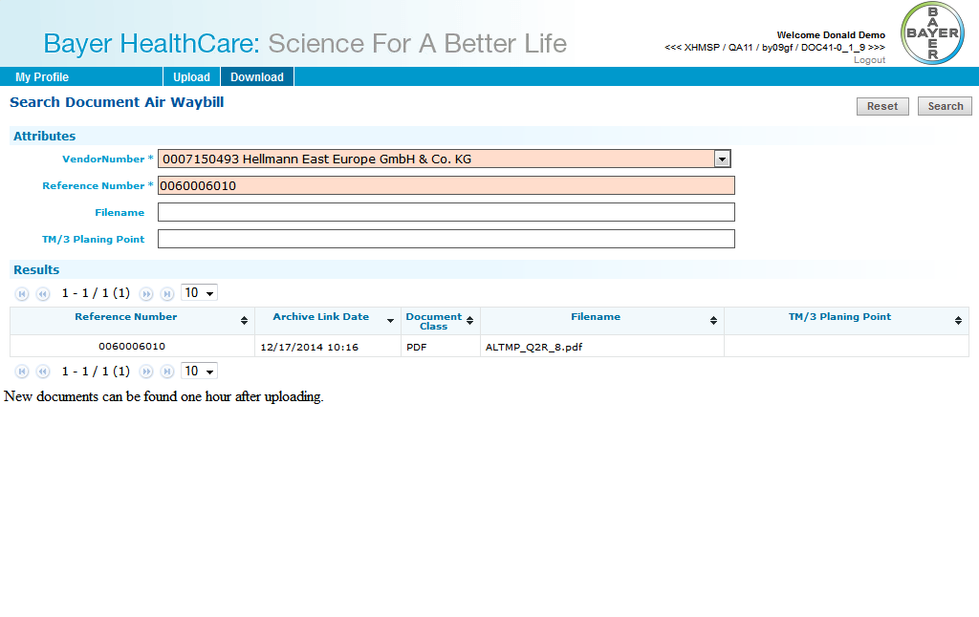

### Download: Bill of Lading

If you want to download a bill of lading, please select “Bill of Lading” from the Download-tab in your top navigation menu.

You have to select a vendor from the list. If the vendor is not in your list please contact your administrator.

You have to enter the reference number of the document.

Optional you can enter the exact filename.

Optional you can enter the exact TM/3 planing point name.

All found documents will be displayed in the Results-table.

To download a file you just have to click on the row of the file.

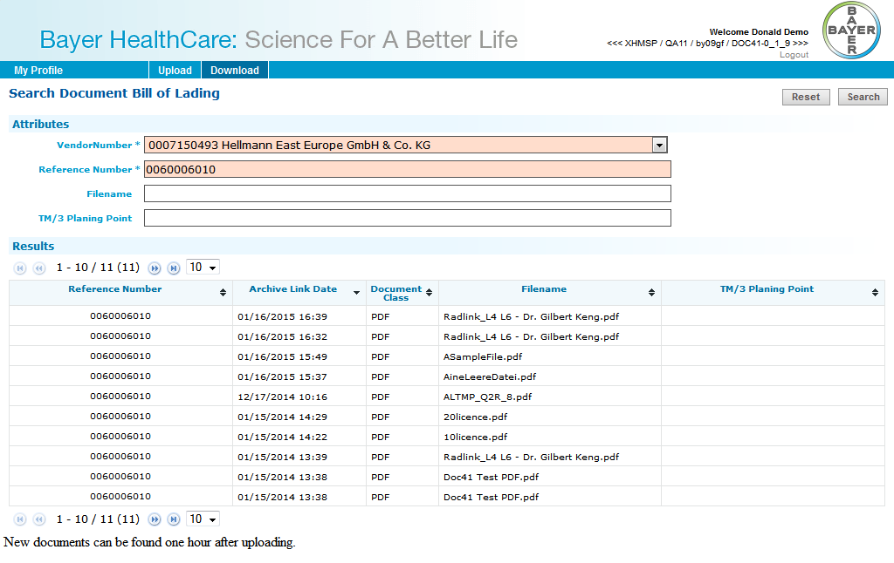

### Download: Shippers declaration

If you want to download a shipers declaration, please select “Shippers Declaration” from the Download-tab in your top navigation menu.

You have to select a vendor from the list. If the vendor is not in your list please contact your administrator.

You have to enter the reference number of the document.

Optional you can enter the exact filename.

Optional you can enter the exact TM/3 planing point name.

All found documents will be displayed in the Results-table.

To download a file you just have to click on the row of the file.

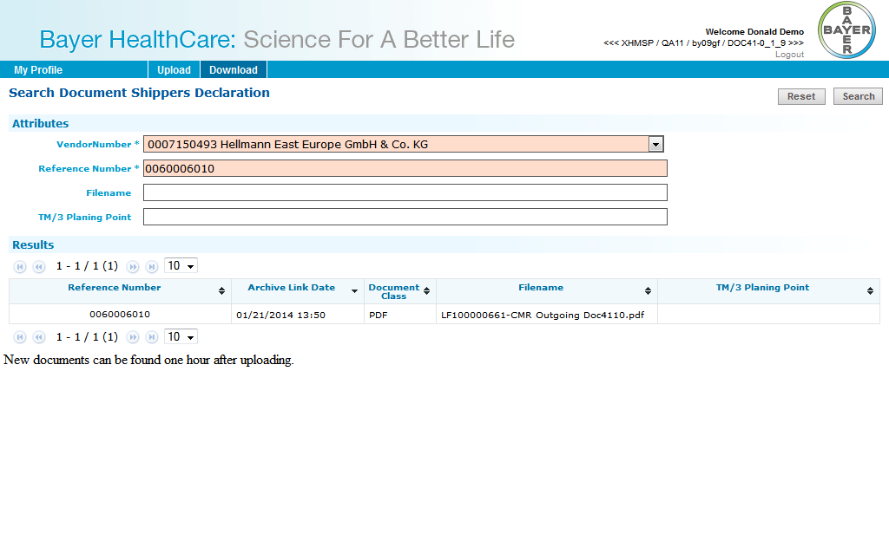

### Download: Waybill

If you want to download a waybill, please select “Waybill” from the Download-tab in your top navigation menu.

You have to select a vendor from the list. If the vendor is not in your list please contact your administrator.

You have to enter the reference number of the document.

Optional you can enter the exact filename.

Optional you can enter the exact TM/3 planing point name.

All found documents will be displayed in the Results-table.

To download a file you just have to click on the row of the file.

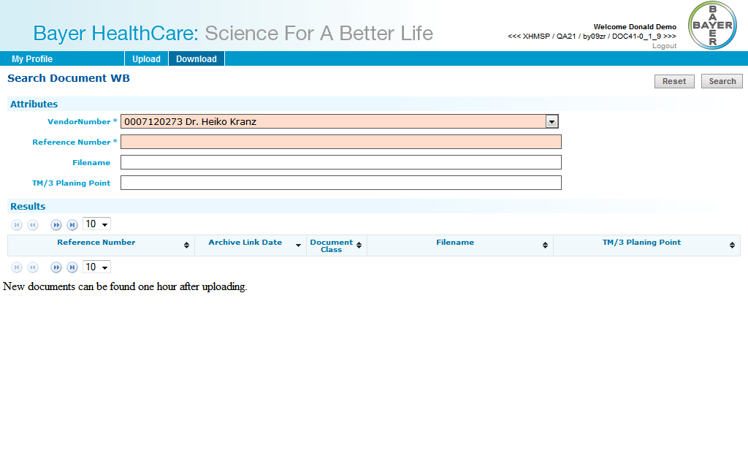

### Download: FDA certificate

If you want to download a FDA certificate, please select “FDA Certificate” from the Download-tab in your top navigation menu.

You have to select a vendor from the list. If the vendor is not in your list please contact your administrator.

You have to enter the reference number of the document.

Optional you can enter the exact filename.

Optional you can enter the exact TM/3 planing point name.

All found documents will be displayed in the Results-table.

To download a file you just have to click on the row of the file.

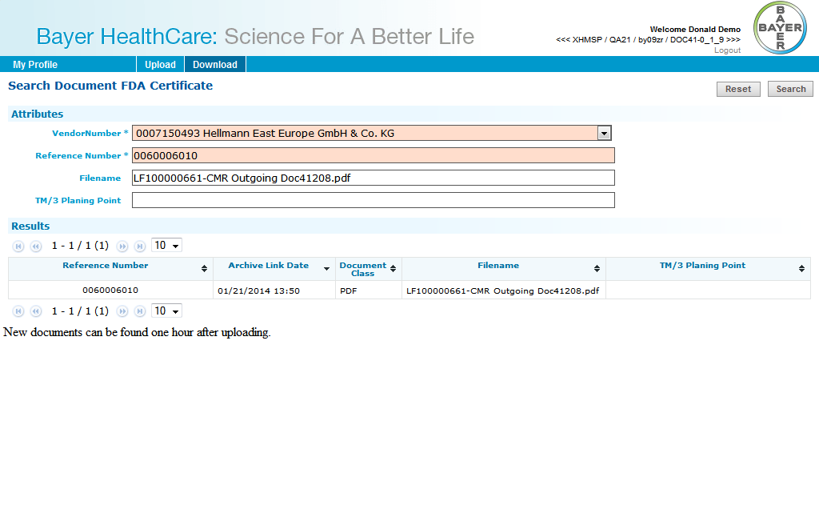

### Download: CMR Outgoing

If you want to download a CMR outgoing, please select “CMR Outgoing” from the Download-tab in your top navigation menu.

You have to select a vendor from the list. If the vendor is not in your list please contact your administrator.

You have to enter the reference number of the document.

Optional you can enter the exact filename.

Optional you can enter the exact TM/3 planing point name.

All found documents will be displayed in the Results-table.

To download a file you just have to click on the row of the file.

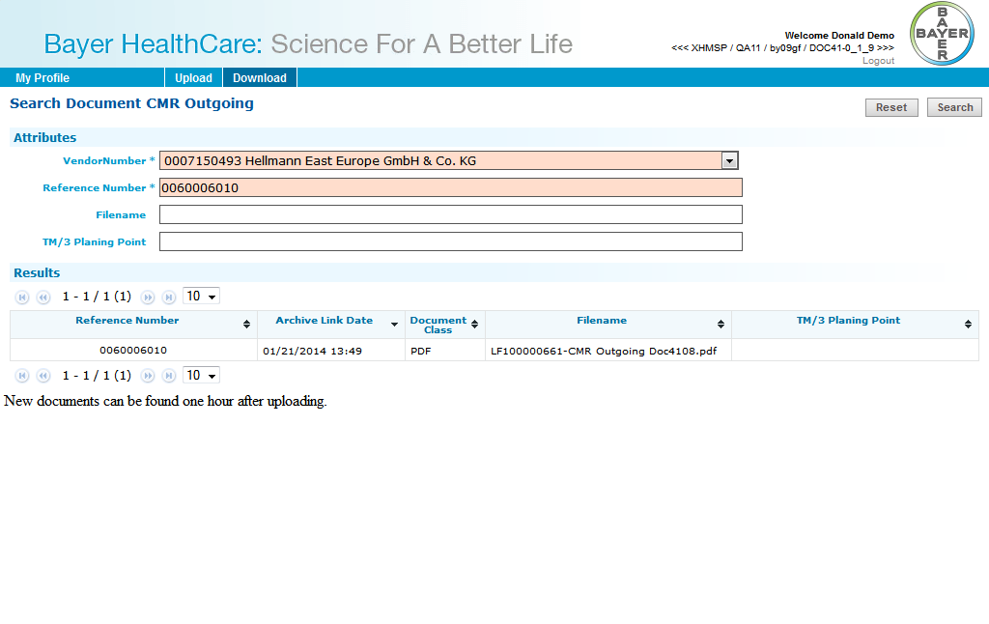

### Upload: CMR Incoming

If you want to upload a CMR incoming, please select “CMR Incoming” from the Upload-tab in your top navigation menu.

You have to select a vendor from the list. If the vendor is not in your list please contact your administrator.

You have to enter the reference number of the document.

Optional you can enter the exact filename.

Optional you can enter the TM/3 planning point name.

You have to select a document file to upload.

Optional you can enter an E-Mail-Address to send an E-Mail after uploading the file.  
Multiple addresses are given as a list of strings separated by one of the following characters: ';', ',', ' ', '/','\'

You can display Deliveries/Shipping Units without Bill of Lading by clicking on the corresponding button on the top.

To upload the file you have to click on the button on the upper right.

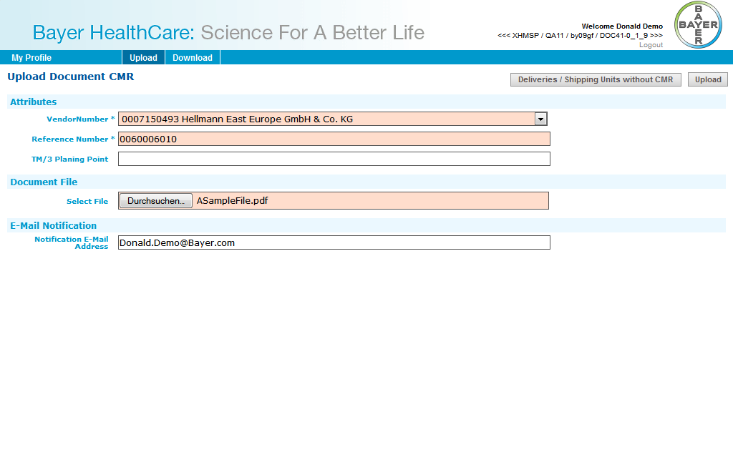

### Upload: Air waybill

If you want to upload an air waybill, please select “Air waybill” from the Upload-tab in your top navigation menu.

You have to select a vendor from the list. If the vendor is not in your list please contact your administrator.

You have to enter the reference number of the document.

Optional you can enter the exact filename.

Optional you can enter the TM/3 planning point name.

You have to select a document file to upload.

Optional you can enter an E-Mail-Address to send an E-Mail after uploading the file.  
Multiple addresses are given as a list of strings separated by one of the following characters: ';', ',', ' ', '/','\'

You can display Deliveries/Shipping Units without Bill of Lading by clicking on the corresponding button on the top.

To upload the file you have to click on the button on the upper right.

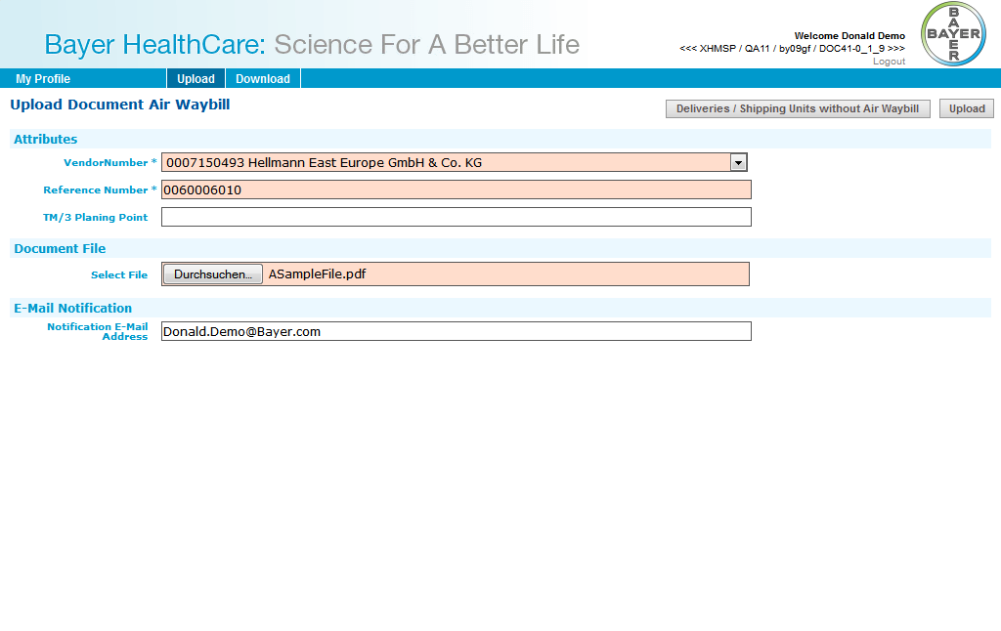

### Upload: Bill of Lading

If you want to upload a Bill of Lading, please select “Bill of Lading” from the Upload-tab in your top navigation menu.

You have to select a vendor from the list. If the vendor is not in your list please contact your administrator.

You have to enter the reference number of the document.

Optional you can enter the exact filename.

Optional you can enter the TM/3 planning point name.

You have to select a document file to upload.

Optional you can enter an E-Mail-Address to send an E-Mail after uploading the file.  
Multiple addresses are given as a list of strings separated by one of the following characters: ';', ',', ' ', '/','\'

You can display Deliveries/Shipping Units without Bill of Lading by clicking on the corresponding button on the top.

To upload the file you have to click on the button on the upper right.

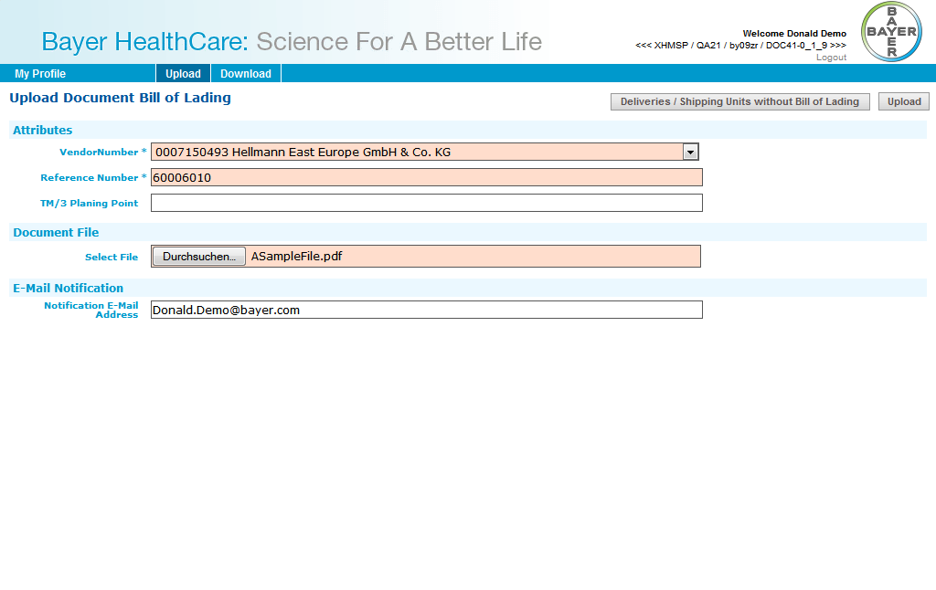

## (SD) Customs Broker

### DirectDownload: Air waybill

You will receive a direct link to the document. After clicking on the link you have to login with your username and password. You can download the document directly than.

### DirectDownload: Bill of Lading

You will receive a direct link to the document. After clicking on the link you have to login with your username and password. You can download the document directly than.

### DirectDownload: Shippers declaration

You will receive a direct link to the document. After clicking on the link you have to login with your username and password. You can download the document directly than.

### DirectDownload: Waybill

You will receive a direct link to the document. After clicking on the link you have to login with your username and password. You can download the document directly than.

### DirectDownload: FDA certificate

You will receive a direct link to the document. After clicking on the link you have to login with your username and password. You can download the document directly than.

## (QM) Material Supplier

### Upload: Supplier CoA

If you want to upload a supplier CoA, please select “Supplier CoA” from the Upload-tab in your top navigation menu.

You have to select a vendor from the list. If the vendor is not in your list please contact your administrator.

You have to enter the vendor batch.

You have to select a plant from the list. If the plant is not in your list please contact your administrator.

Click on the button on the upper right to continue.

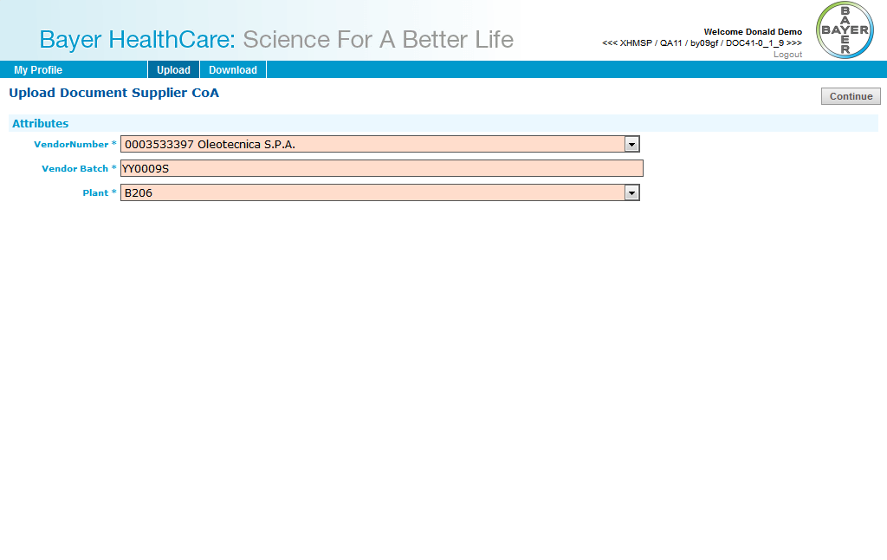

## (QM) Product Supplier

### Upload: Delivery Certificate

If you want to upload a Delivery Certificate, please select “Delivery Certificate” from the Upload-tab in your top navigation menu.

You have to select a vendor from the list. If the vendor is not in your list please contact your administrator.

You have to select a plant from the list. If the plant is not in your list please contact your administrator.

You have to enter at least one of Material, Batch or Order ID.

Click on the button on the upper right to continue.

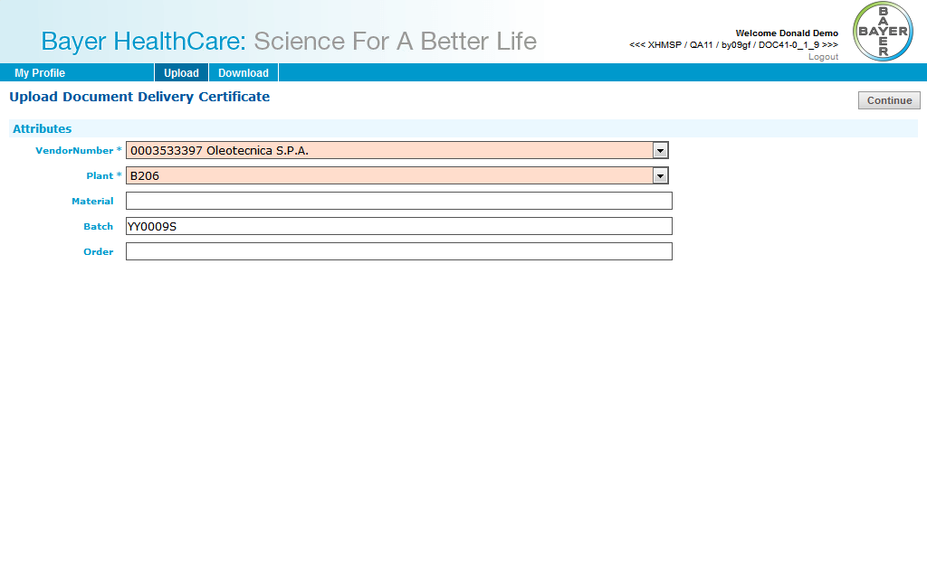

You have to select a country from the list. If the country is not in your list please contact your administrator.

You have to select a document file to upload.

Optional you can enter an E-Mail-Address to send an E-Mail after uploading the file.  
Multiple addresses are given as a list of strings separated by one of the following characters: ';', ',', ' ', '/','\'

To upload the file you have to click on the button on the upper right.

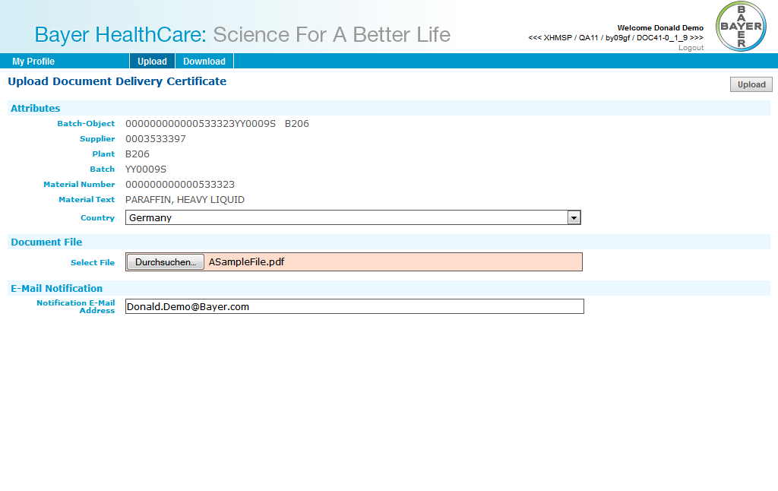

## (QM) Delivery Certificate Viewer Country

### Download: Delivery Certificate Country

If you want to download a delivery certificate for a country, please select “Delivery Certificate Country” from the Download-tab in your top navigation menu.

You have to select a country from the list. If the country is not in your list please contact your administrator.

You have to enter at least one of material number or batch.

All found documents will be displayed in the Results-table.

To download a file you just have to click on the row of the file.

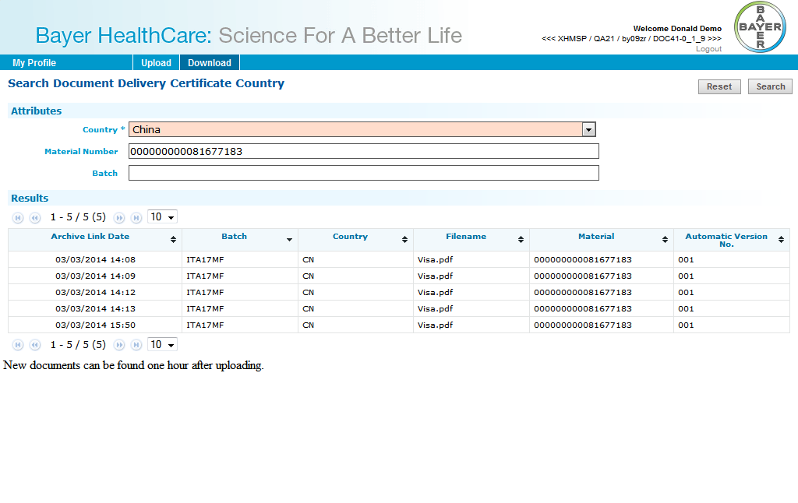

## (QM) Delivery Certificate Viewer Customer

### Download: Delivery Certificate Customer

If you want to download a delivery certificate for a customer, please select “Delivery Certificate Customer” from the Download-tab in your top navigation menu.

You have to select a customer from the list. If the country is not in your list please contact your administrator.

You have to select a country from the list. If the country is not in your list please contact your administrator.

You have to enter a delivery number.

You have to enter at least one of material number or batch.

All found documents will be displayed in the Results-table.

To download a file you just have to click on the row of the file.

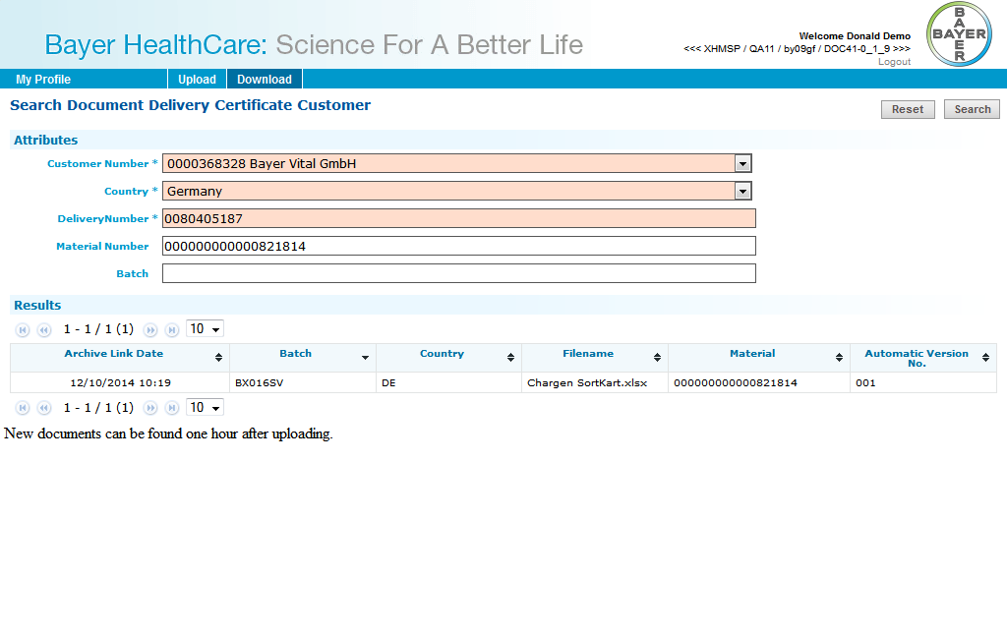

## (PTMS) Layout Supplier

### Download: LowRes Artwork

If you want to download a low res artwork for layout supplier, please select “Artwork Low Res for Layout Supplier” from the Download-tab in your top navigation menu.

You have to select a vendor from the list. If the vendor is not in your list please contact your administrator.

You have to enter a material.

Optional you can enter the exact filename.

All found documents will be displayed in the Results-table.

To download a file you just have to click on the row of the file.

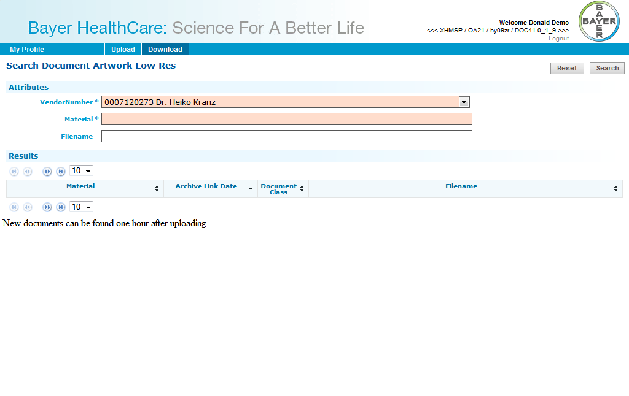

### Download: HighRes Layout

If you want to download a high res artwork for layout supplier, please select “Artwork High Res for Layout Supplier” from the Download-tab in your top navigation menu.

You have to select a vendor from the list. If the vendor is not in your list please contact your administrator.

You have to enter a material.

Optional you can enter the exact filename.

All found documents will be displayed in the Results-table.

To download a file you just have to click on the row of the file.

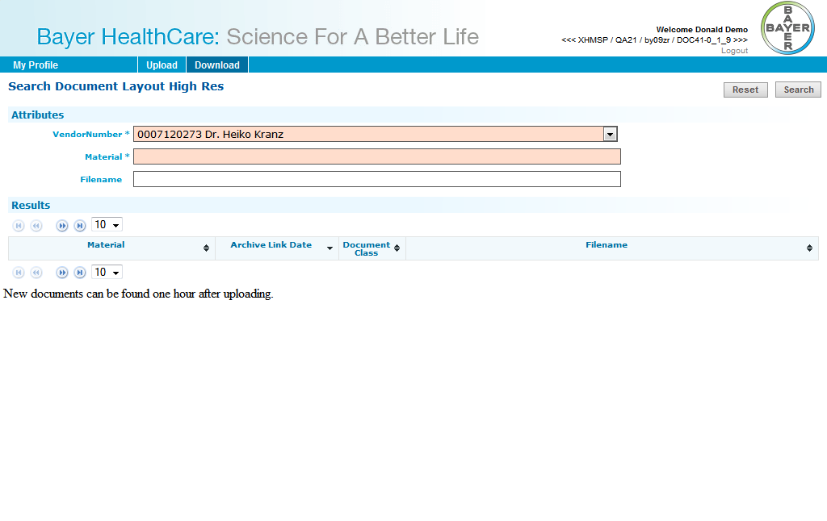

### Download: Packaging Material Specification

If you want to download a packaging material specification for layout supplier, please select “Packaging Material Specification for Layout Supplier” from the Download-tab in your top navigation menu.

You have to select a vendor from the list. If the vendor is not in your list please contact your administrator.

You have to enter a material.

Optional you can enter a document description, a PLM document type and/or version.

All found documents will be displayed in the Results-table.

To download a file you just have to click on the row of the file.

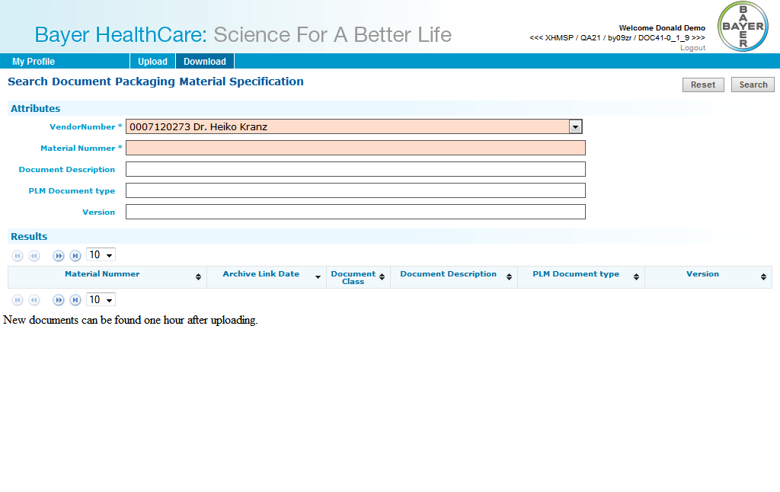

### Download: Technical Drawing PZ

If you want to download a technical drawing for layout supplier, please select “Technical Drawing PZ for Layout Supplier” from the Download-tab in your top navigation menu.

You have to select a vendor from the list. If the vendor is not in your list please contact your administrator.

You have to enter a material.

Optional you can enter a document description, a PLM document type and/or version.

All found documents will be displayed in the Results-table.

To download a file you just have to click on the row of the file.

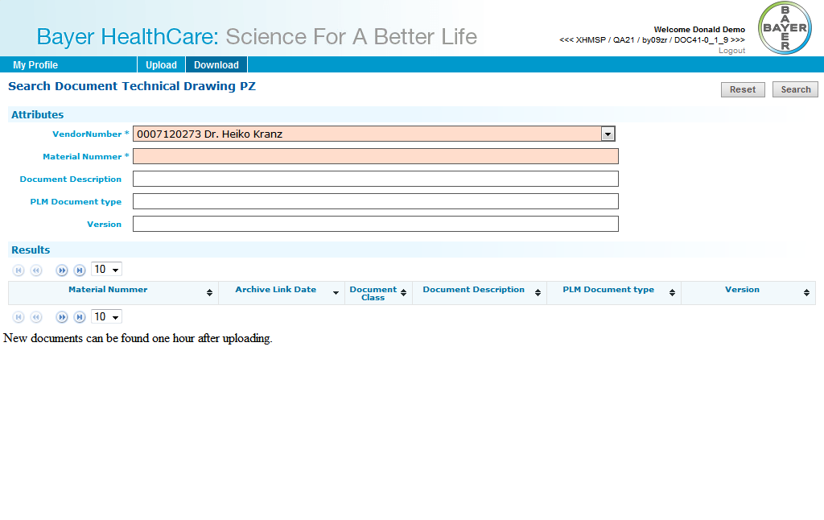

### Upload: LowRes Artwork

If you want to upload a low res artwork for layout supplier, please select “Artwork LowRes” from the Upload-tab in your top navigation menu.

You have to select a vendor from the list. If the vendor is not in your list please contact your administrator.

You have to enter the material.

You have to select a document file to upload.

Optional you can enter an E-Mail-Address to send an E-Mail after uploading the file.  
Multiple addresses are given as a list of strings separated by one of the following characters: ';', ',', ' ', '/','\'

To upload the file you have to click on the button on the upper right.

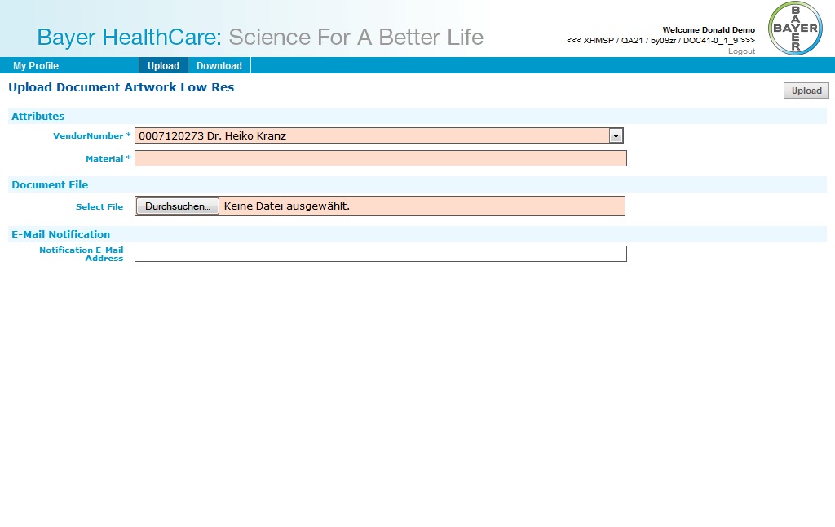

### Upload: HighRes Layout

If you want to upload a high res artwork for layout supplier, please select “Artwork HighRes” from the Upload-tab in your top navigation menu.

You have to select a vendor from the list. If the vendor is not in your list please contact your administrator.

You have to enter the material.

You have to select a document file to upload.

Optional you can enter an E-Mail-Address to send an E-Mail after uploading the file.  
Multiple addresses are given as a list of strings separated by one of the following characters: ';', ',', ' ', '/','\'

To upload the file you have to click on the button on the upper right.

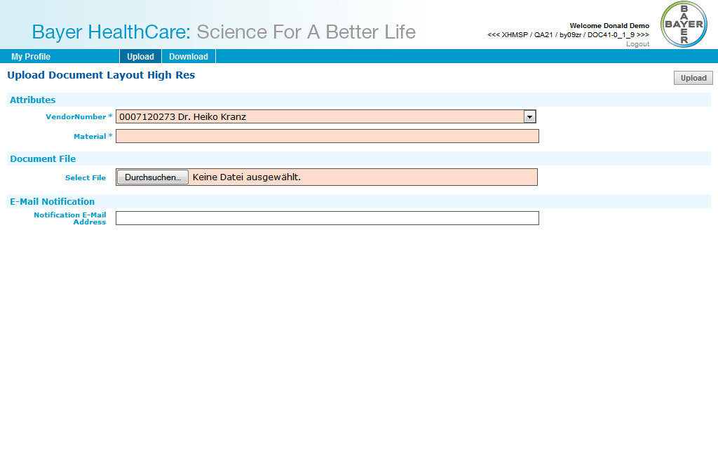

## (PTMS) PM Supplier

### Download: LowRes Artwork

If you want to download a low res artwork for PM supplier, please select “Artwork Low Res for PM Supplier” from the Download-tab in your top navigation menu.

You have to select a vendor from the list. If the vendor is not in your list please contact your administrator.

You have to enter a material.

You have to enter a PO number.

Optional you can enter the exact filename.

All found documents will be displayed in the Results-table.

To download a file you just have to click on the row of the file.

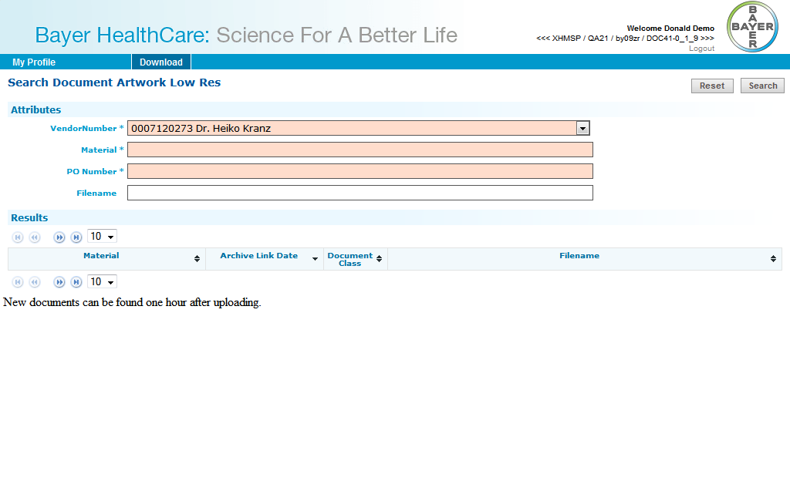

### Download: HighRes Layout

If you want to download a high res artwork for PM supplier, please select “Artwork High Res for PM Supplier” from the Download-tab in your top navigation menu.

You have to select a vendor from the list. If the vendor is not in your list please contact your administrator.

You have to enter a material.

You have to enter a PO number.

Optional you can enter the exact filename.

All found documents will be displayed in the Results-table.

To download a file you just have to click on the row of the file.

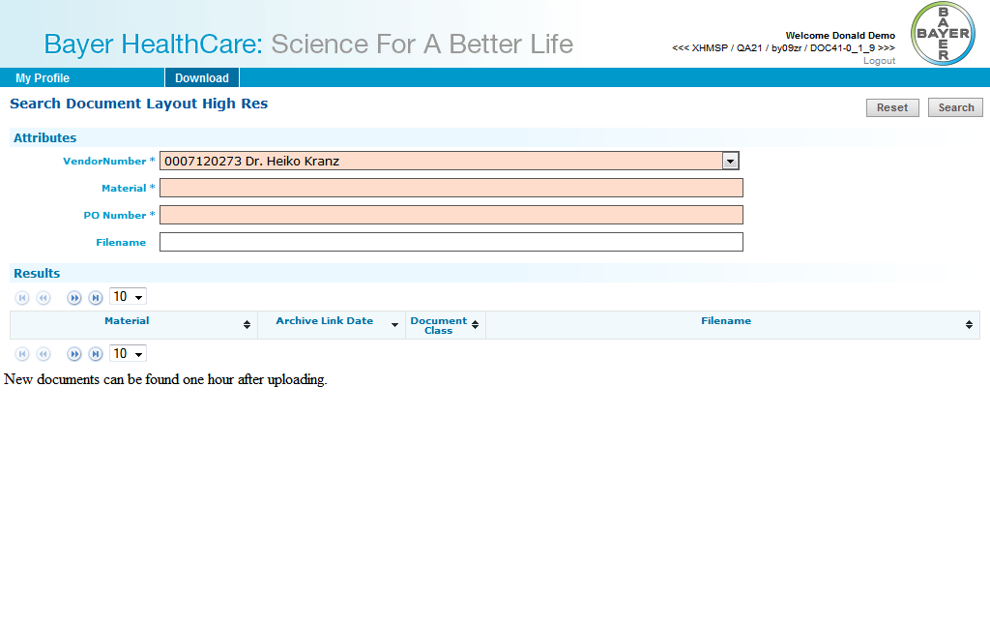

### Download: Packaging Material Specification

If you want to download a packaging material specification for PM supplier, please select “Packaging Material Specification for PM Supplier” from the Download-tab in your top navigation menu.

You have to select a vendor from the list. If the vendor is not in your list please contact your administrator.

You have to enter a material.

You have to enter a PO number.

Optional you can enter a document description, a PLM document type and/or version.

All found documents will be displayed in the Results-table.

To download a file you just have to click on the row of the file.

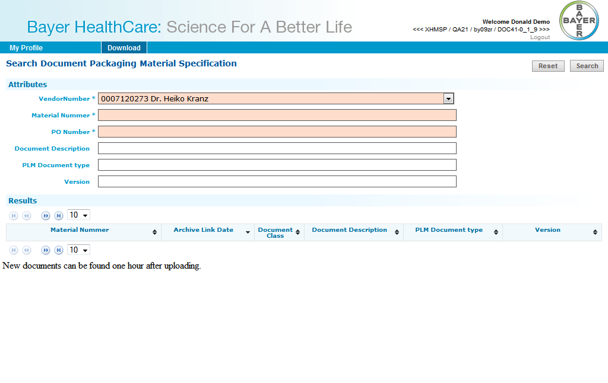

### Download: Technical Drawing PZ

If you want to download a technical drawing for PM supplier, please select “Technical Drawing PZ for PM Supplier” from the Download-tab in your top navigation menu.

You have to select a vendor from the list. If the vendor is not in your list please contact your administrator.

You have to enter a material.

You have to enter a PO number.

Optional you can enter a document description, a PLM document type and/or version.

All found documents will be displayed in the Results-table.

To download a file you just have to click on the row of the file.

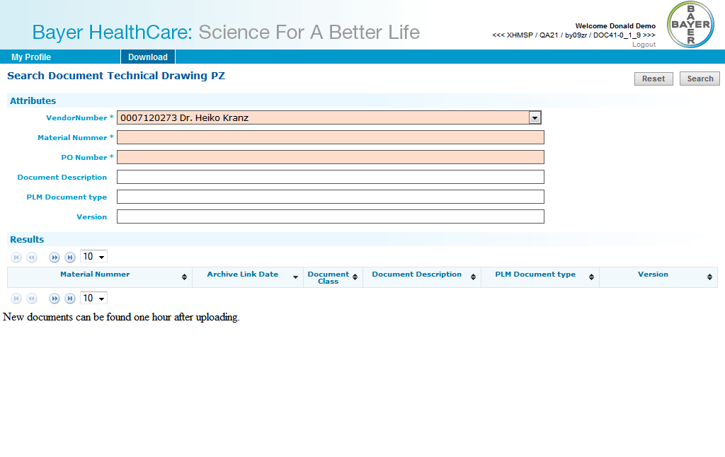

### Download: Technical Packaging and Delivery Requirements

If you want to download a technical drawing for PM supplier, please select “Technical Drawing PZ for PM Supplier” from the Download-tab in your top navigation menu.

You have to select a vendor from the list. If the vendor is not in your list please contact your administrator.

You have to enter a material.

You have to enter a PO number.

Optional you can enter a document description, a PLM document type and/or version.

All found documents will be displayed in the Results-table.

To download a file you just have to click on the row of the file.

